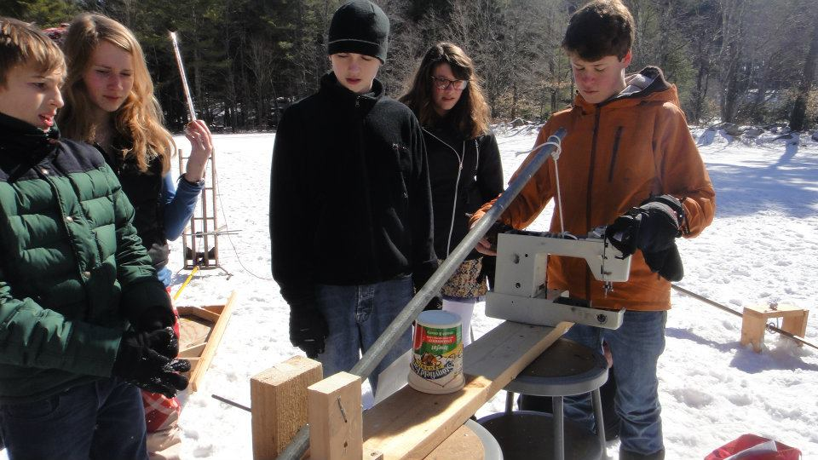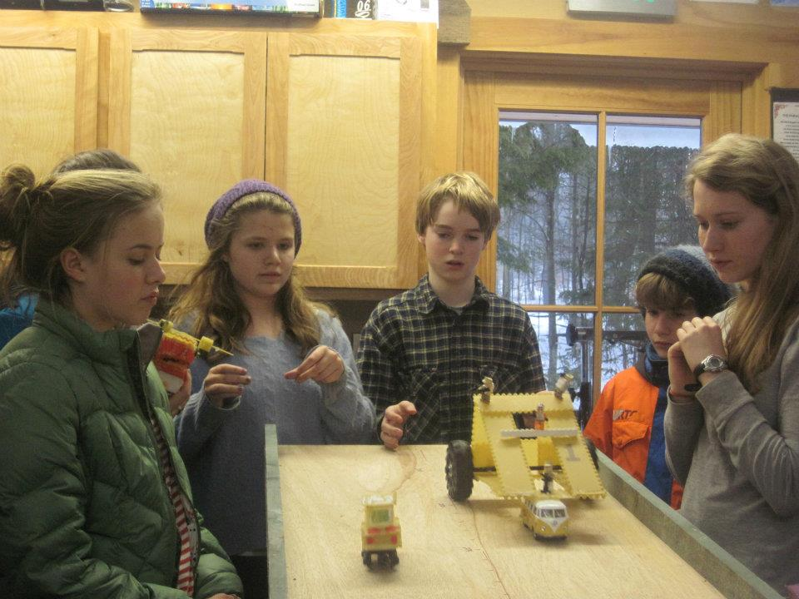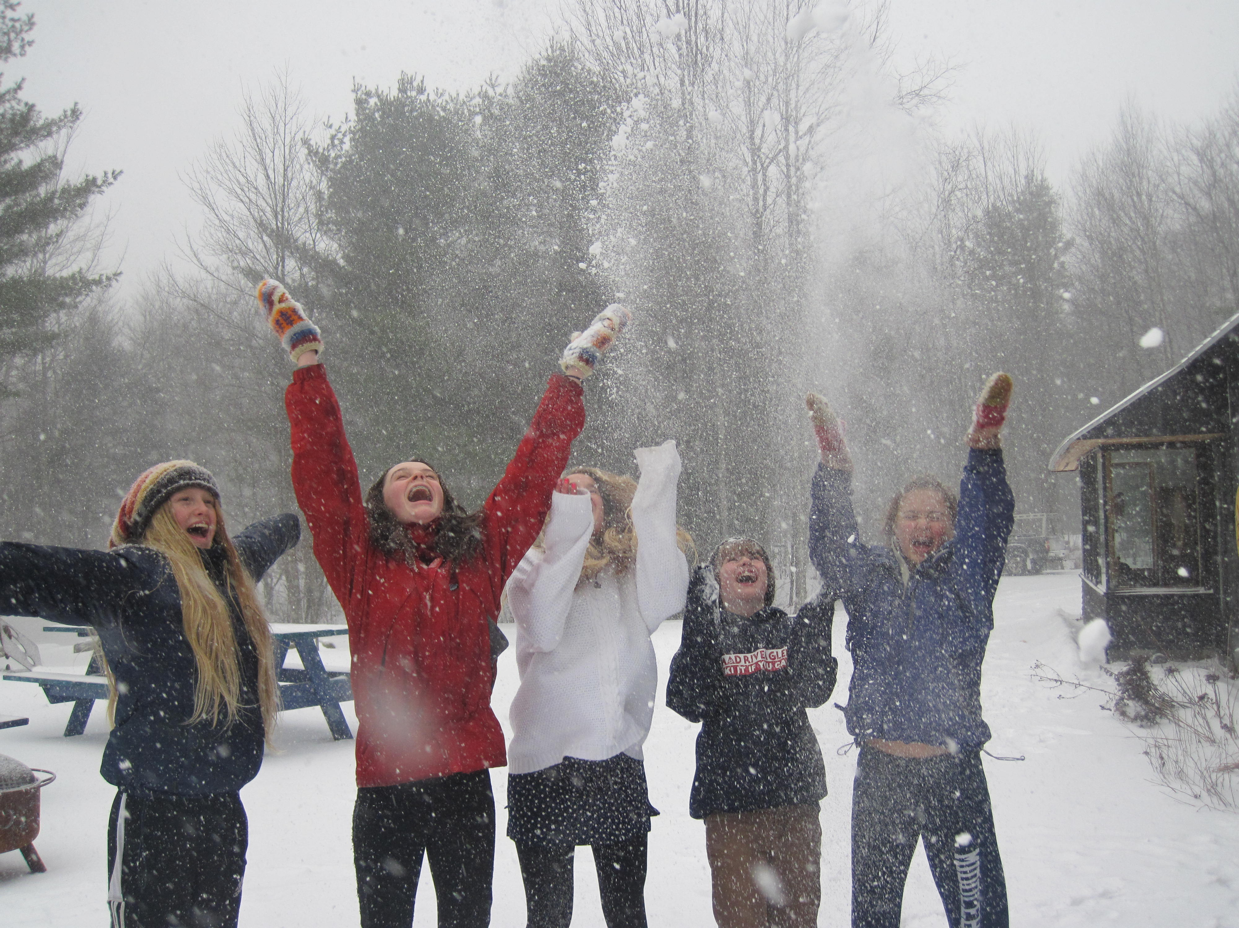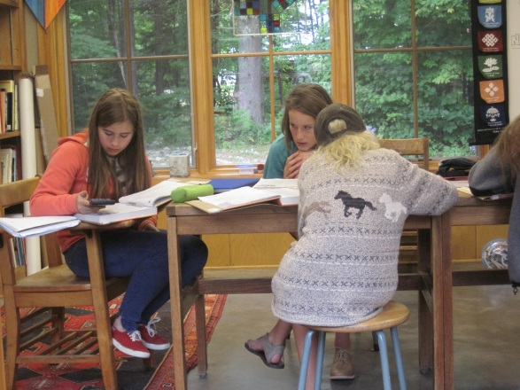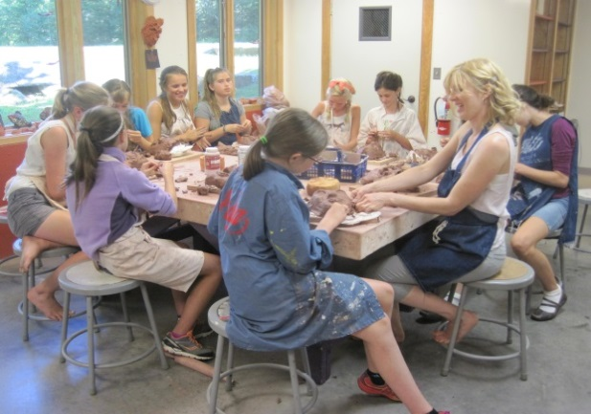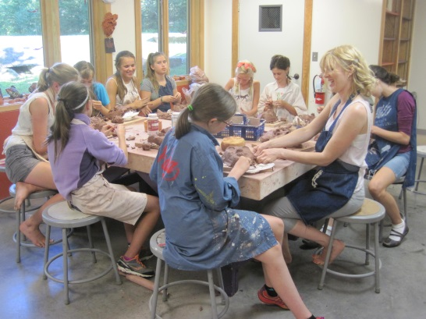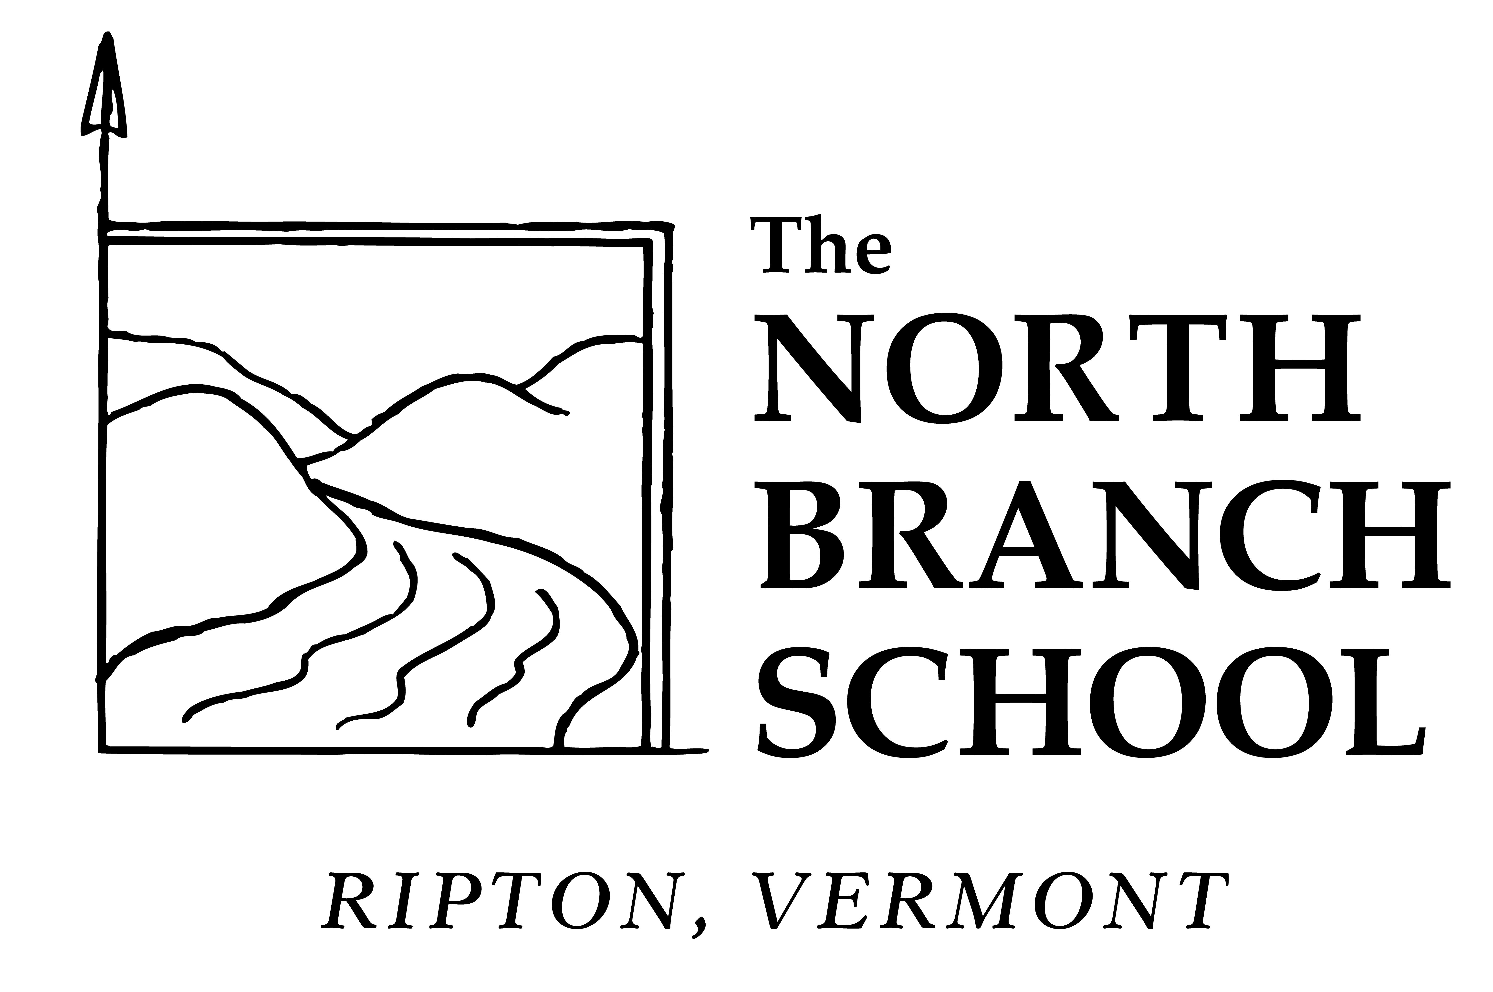

Call us at 388-3269 for an application and more information.

visit us at www.northbranchschool.org

The North Branch School is a non-profit, independent school serving middle school age children (grades 7-9) in Ripton, Vermont.

Now Accepting Applications for the 2015-16 School Year

The North Branch School

Sunday, January 25 3:30-5:00 PM

Informational Meeting at

The North Branch School

for prospective 7th grade students and their families

The North Branch School is a non-profit, independent school serving middle school age children (grades 7-9) in Ripton, Vermont.  Education at NBS is centered on self-directed and active experiential learning that fosters a strong community based on close student-teacher-parent relationships.  With twenty-seven students and a low student/teacher ratio, The North Branch School is able to build a flexible, personalized and engaging environment.

The curriculum is designed as a three-year experience encouraging a safe, intimate learning community in which students can make the important transition from the elementary grades to high school. The North Branch School is committed to using the changes experienced by middle school students as an organizing touchstone throughout the curriculum—as a way of educating the whole child and making school relevant to heart, mind, body and soul.

Contact the school for application materials and more information

388-3269

www.northbranchschool.org

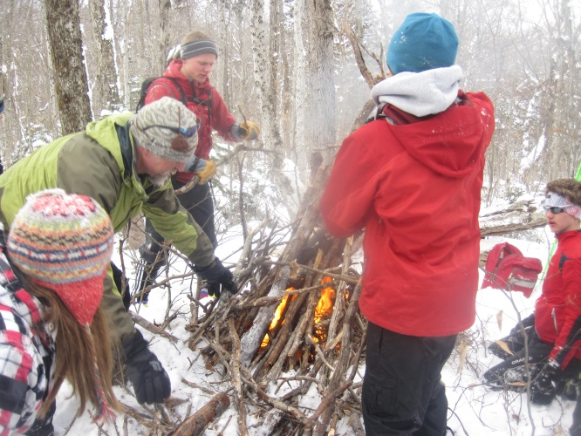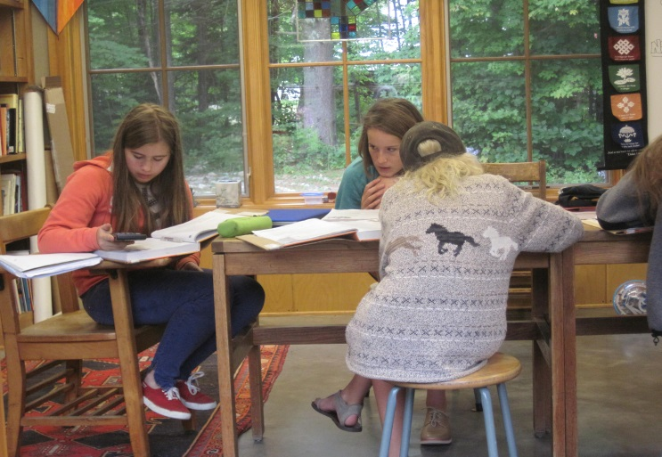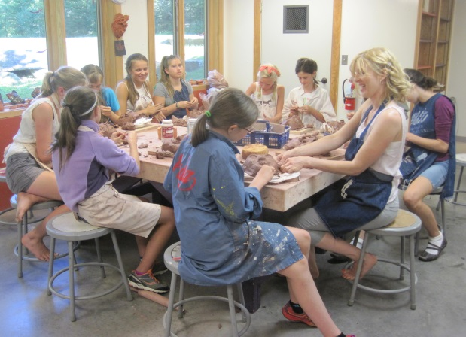

The North Branch School is a non-profit, independent middle school in Ripton, Vermont serving students grades 7-9

tuition assistance is available

Informational Meeting / Open House

for prospective 7th grade students and their families

Sunday, January 25th from 3:30-5:00 PM

call NBS at 388-3269 for more information

or “contact us” at www.northbranchschool.org

The North Branch School

